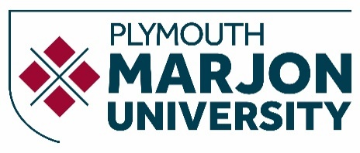

Module Descriptor
Definitive Document

Module Code | BSNF51
Version | (completed by QASU)
Module Title | Academic Skills
Credits | Select 40
Valid From | (completed by QASU)
Status | Proposed
Subject Board | (completed by QASU)
HECoS Code
Academic Level (FHEQ) | Select
Study Period | A
Prerequisites and co-requisites | N/A
Not available to students taking/having taken | N/A

Content (Indicative)
This module outlines what basic academic skills are needed at university level, introducing critical thinking, self-directed learning and referencing.

- ​​The principles of university level study including critical thinking, reflective practice, learning styles and research skills. ​
- ​​Strategies to self-direct learning and engage in guided independent study.​
- ​​The fundamental principles and techniques of a referencing system.​

Teaching and Learning Experience
- Guided Independent Study
- Lectures
- Seminars

Module Learning Outcomes (MLOs)
On successful completion of this module students will be able to:

1. Prepare an action plan for engaging in guided independent study.
2. Critique chosen literature.
3. Apply the principles and techniques of referencing.​
4. Explain and review the theory of self-directed learning and the principles of critical thinking.

Assessment
Assessment Task | Weighting | Module Learning Outcomes Assessed
Literature Review | Pass/fail | 2, 3
Reflective Portfolio | 100% | 1, 4

Indicative reading

Books
Cottrell, S. (2023) Critical Thinking Skills: Effective Analysis, Argument and Reflection (Palgrave Study Skills), 4th Edition, Palgrave: UK.
Cottrell, S. (2013) The Study Skills Handbook (Palgrave Study Skills), 4th Edition, Palgrave: UK.
Pears, R. (2022) Cite Them Right: The Essential Referencing Guide (Palgrave Study Skills), Palgrave: UK.

Journals
International Journal of Entrepreneurial Behaviour & Research

Websites
http://www.citethemrightonline.com/
http://www.academicskills.marjon.ac.uk
http://he.palgrave.com/studentstudyskills
gttp://www.ucas.com/ucas/undergraduate/preparing-your-studies/study-skills-guide

