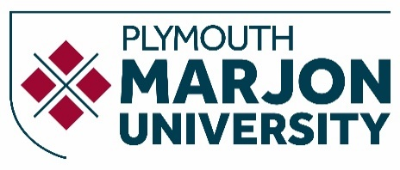

Module Descriptor
Definitive Document

Module Code | BSNC52
Version | (completed by QASU)
Module Title | Academic, Personal and Professional Development
Credits | 20
Valid From | (completed by QASU)
Status | Proposed
Subject Board | (completed by QASU)
HECoS Code
Academic Level (FHEQ) | 4
Study Period | A
Prerequisites and co-requisites | None
Not available to students taking/having taken | N/A

Content (Indicative)
This module will develop students’ engagement with their own personal and academic development in order to support them as they make the step up to degree-level study within the university environment. It will include the following content:
- Reflection on academic, personal and professional aspirations and engagement in personal development planning to achieve these.
- A broad understanding of the sector or sectors of employment related to their programme of study.
- How to manage oneself at university, access and create resources and develop the core knowledge, skills and attributes of enterprising graduates.

Teaching and Learning Experience
- Lectures
- Seminars
- Guided Independent Study
- Networking events

Module Learning Outcomes (MLOs)
On successful completion of this module students will be able to:
1. Identify the sector(s) of employment related to their programme of study.
2. Discuss the core knowledge, skills and attributes of enterprising graduates.
3. Reflect upon current knowledge, skills and experience and applicability for operating as an employee or entrepreneur.
4. Plan personal development opportunities.

Assessment
Assessment Task | Weighting | Module Learning Outcomes Assessed
Reflective Portfolio | 100% | 1-4

Indicative reading

Books
Burns, T., & Sinfield, (2022). Essential study skills: The complete guide to success at University. (5th ed.). Sage.
Carnegie, D. (2006). How to win friends and influence people. Vermilion. Covey, S. R. (2004). The 7 habits of highly effective People. Simon and Schuster UK Ltd.
McFarlan, B. (2003). Drop the pink elephant. Capstone.
Sage. Kelly, M. (2016). Social media for your student and graduate job search. Palgrave Career
Skills.
Smale, B., & Fowlie, J. (2015). How to succeed at university: An essential guide to academic skills and personal development. Sage.
Tissington, P., Hasel, M., & Matthiesen, J. (2017). How to write successful business and management essays. Sage.

Journals
Career Development International
Education + Training
European Journal of Training and Development
Journal of Career Development
Journal of Workplace Learning

Websites
www.academicskills.marjon.ac.uk
www.belbin.com
CMI resources

